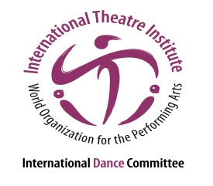
International Dance Symposium
of the 35th ITI World Congress
18 to 20 July 2017, in Segovia, Spain
“The city is our stage; the stage is our nature”

Workshop Submission
Please fill in the information in the space provided below and send it to alma.llerena@itispain.es along with your CV and the dossier no later than 1 May 2017.

Workshop title

Workshop description in one line

Detailed workshop description (max. 500 words)

Workshop leader

Duration

Website / videos

Technical needs (please be VERY specific and list everything you will need).

List of workshop leaders that would be traveling to Segovia
1.
2.
3. etc.

Full Name

Address

City / Zip Code / Country

Phone (with country code)

Email

