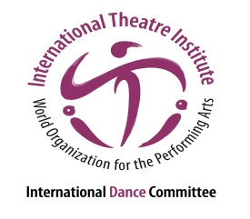
International Dance Symposium
of the 35th ITI World Congress
18 to 20 July 2017, in Segovia, Spain
“The city is our stage; the stage is our nature”

Performance Submission
Please fill in the information in the space provided below and send it to alma.llerena@itispain.es along with your CV and the dossier no later than 1 May 2017.

Performance title

Performance description in one line

Detailed performance description (max. 500 words)

Director

Choreography

Dramaturgy

Music Composition / Interpretation
Set design

Costume design

Light design

Dancers

Duration

Website / Trailer / Performance

Technical needs (please be VERY specific and list everything you will need).

List of artists traveling to Segovia for the performance
1.
2.
3. etc.

Full Name

Address

City / Zip Code / Country

Phone (with country code)

Email

