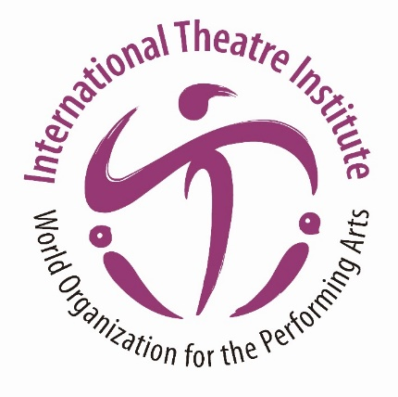
International Theatre Institute ITI
World Organization for the Performing Arts
Message for International Dance Day 2022 – 29 April
Author of the Message: KANG Sue-jin, South Korea
Dancer, Artistic Director of the Korean National Ballet
English translation from the Korean original
International Dance Day Message 2022 by KANG Sue-jin
The Covid-19 catastrophe has stopped life as we so freely knew it and being amidst this tragedy makes us rethink the meaning of “dance” and “dancers” In the distant past, dance was a primal means of expression and communication through gestures; becoming performance art that moved the soul and inspired the audience. It is a momentary art that is difficult to restore to its original form once completed because it`s created with the entire body and soul. Dance is made of ephemeral moments, which destines dancers to be on the move forever. Yet, Covid-19 has restricted and even blocked the art of dance in its original form.

Even though the situation is improving, dance performances are still subject to many restrictions. This makes us cherish the precious memories of times when dance and dancers sparkled like jewels, conveying human anguish and anxiety, will and hope for life, and illuminated the world.

Similarly, it is important to recall that during the aftershocks of the Black Death in Medieval Europe, the ballet Giselle depicting love beyond death was performed at the Paris Opera on 28 June 1841 and received an explosive response. Since then, Giselle has been performed all over Europe and around the world to comfort and encourage the souls of mankind ravaged by the pandemic. It is also my understanding of that point, which was first demonstrated in that very performance of Giselle, is the magnificent spirit of a ballerina trying to escape the gravity of the world`s hardships.

The lonely and weary audience is thirsty for the sympathy and comfort of the dancers. As dancers, we believe that the flapping of our wings gives hope to the hearts of those who love the art of dance and gives them the courage to overcome this pandemic.

My heart is already starting to pound.

Kang Sue-jin

