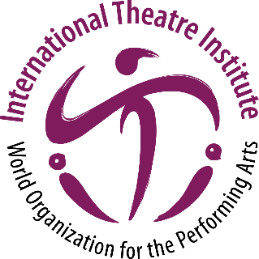
International Theatre Institute ITI
World Organization for the Performing Arts
World Theatre Day 2023 – 27 March
Biography of Samiha AYOUB, Egypt
Egyptian actress
English (translation)
Samiha AYOUB
Egyptian actress
An Egyptian actress, born in the Shubra neighbourhood of Cairo. She graduated from the Higher Institute of Dramatic Arts in 1953, where she was taught by the playwright, Zaki Tulaimat. Her credits on the stage over the course of her artistic career amounted to approximately 170 plays, including Raba’a Al-Adawiya, Sekkat Al-Salamah, Blood on the Curtains of the Kaaba, Agha Memnon, The Caucasian Chalk Circle. Although theatrical works dominated the majority of her artwork, she had many contributions in cinema and television. In the cinema, she was distinguished through several films, including The Land of Hypocrisy, The Dawn of Islam, With Happiness, Among the Ruins, and on television, she presented many prominent works of the most important of which are Stray Light, Time for Roses, Amira in Abdeen, Al-Masrawiya. She received many honours from several presidents, including Gamal Abdel Nasser and Anwar Sadat, as well as Syrian President Hafez al-Assad and French Giscard d'Estaing.

