

**Georgian New Theatre Festival-Show Case 2024 /GNTFS/**

**1-4 February, Tbilisi, Georgia**

**Project in co-operation with UNESCO ITI Georgian Centre, EFA/EFFE South Caucasus Hub and Arts Research Institute of Georgia**

You are invited to attend Georgian New Theatre – Festival and Show case first edition in 2024.

If you are festival director, programmer, tour organizer and interesting to bring to your country or events of Georgian New Theatre, we are looking forward to see you 1-4 February of 2024 in Tbilisi, Georgia.

First Time 3 generations of Georgian Theatre Directors at the Georgian New Theatre and international projects, in one showcase, best performances, roundtable-meetings with directors and actors, discussions about cooperation and exchanges, presentations.

Selected participants /one per institution/ will be host by the program, and will be covered their local accommodation and meals. Other participants still could take part with registration fee, free access to all program and special discount prices for local expenses.

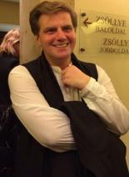**Artistic Director of the New Theatre – David Doiashvili**

**Program Curator Dr. Levan Khetaguri, SG of UNESCO ITI Georgian Centre**

**For any further information please contact us**: [**internationaloffice@newtheatre.ge**](mailto:internationaloffice@newtheatre.ge)

**During 4 working days We are presenting[1]:**

***King Lear-by Shakespeare*,** Director - David Doiashvili

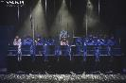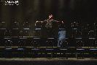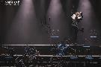  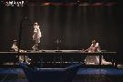 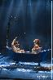 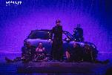 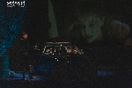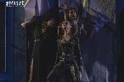

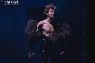 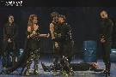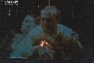

Scenography - Anna Ninua

Costume Designer - David Gevorkov

Composer - Nikoloz Rachveli

Choreographer - Kote Purtseladze

Light Designer - Mikheil Bakradze

Video - Aleksandre Kurdubadze, Lasha Mumladze

Sound engineer - Kakha Khoshtaria, Emzar Begiashvili

Assistant director - Nino Chavchavadze

Cast

King Lear - David Beshitaishvili

King of France - Irakli Japaridze

Duke of Burgundy - Luka Japaridze

Duke of Cornwall - Giorgi Bakhutashvili

Duke of Albany - Andro Chichinadze

Earl of Kent - Tato Chakhunashvili

Earl Gloucester - Otar Lortkipanidze

Edgar - Gigi Karseladze

Edmund - Giviko Baratashvili

Fool - Shako Mirianashvili

Oswald - Zuka Papuashvili

Goneril - Nata Berezhiani

Regan - Eka Demetradze

Cordelia - Manu Tavadze

Music by Nikakoi / Zagareli & Georgian Philharmonic Strings is used in this Production.

About the Play

If your gaze never strays from the shadow of your own crown and you preach without mercy while acting like a Solicitous trivializing dictator, you are not a leader.

If you cut the fate of your country on the model of your own vicious family and distribute it as a dowry, then you will be wholly lost in the abyss, because you think that your main, fabricated role is your own life.

If your haughty hopes are not fulfilled, you shall die from the terrible wrath of heaven! And that is the greatest blessing!! The birth of the child full of suffering, who cautiously starts to perceive and listen to the world beyond, marks the beginning of the transition, metamorphosis, breakthrough, and transformation. Because you yourself never saw that divine synchronicity between the outer world and your inner world that keeps us beyond illusions. You never thought you might even experience the wind inside of you as the storm raged outside. You saw the lightning in yourself as it struck your insides while the thunder boomed over the sky. You were unaware that when the world around you is chaotic, it is much worse and more troublesome within. You have to alter yourself since nothing outside of you can ever be changed.

This is the law of the universe - the only constant and unvarying is change.

Duration 210 min.

**<https://www.facebook.com/StateNewTheatre/videos/1030225537989344>**

**<https://www.facebook.com/StateNewTheatre/videos/6826474424087097>**

The premiere was held on September, 2023

<https://www.youtube.com/watch?v=pmWr-p5KH1A>

***The Cherry Orchard*, Based on *The cherry orchard* by Anton Chekhov.**

 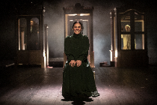

Directed by Andro Enukidze

Costum design and scenography by Shota Bagalishvili

Choreography by Kote Purtseladze

Cast:

Luba Ranevskaya- Buba Gogorishvili

Woman-Ana, Varya, Charlotte- Nana Butkhuzi

Leonid Gayev- Aleksandre Begalishvili

Lopakhin- Giorgi Bakhutashvili

Petya Trophomov- Archil Sologashvili

Simen-pishchik- Badri Begalishvili

About the cast:

Cherry Orchard" is a comedy about the tragedy of people who can't seem to draw a line between what is right and what is harmful.

It is a narrative about individuals who overthink their responsibilities, sometimes to the point where none of them could be fulfilled.

The play features Soso Bagdashvili, Wolfgang Amadeus Mozart, and Joseph Haydn's music.

**Duration of the performance 100m**

***The Seagull*, by Anton Chekhov,** Directed by David Doiashvili

 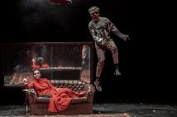 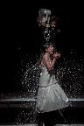

Scenography by Giorgi Ustiashvili

Costumes Designer Anano Mosidze Choreographer Kote Purtseladze Composer Giorgi Shamanauri , Nina Sublatti Lighting Designer Ia Nadirashvili Sound Emzar Begiashvili Assistant to the director Nino Chavchavadze

**Characters and Cast:**

Irina Arkadina - Buba Gogorishvili

Konstantin Treplyov - Giviko Baratashvili

Pjotr Sorin - Aleksandre Begalishvili

Boris Trigorin - David Beshitaishvili

Nina Zarechnaya - Taso Chanturaia

Yevgeny Dorn – Tato Chakhunashvili

Ilya Shamrayev - Badri Begalishvili

Polina Andryevna - Nana Butkhuzi

Masha - Nanka Kalatozishvili

Semyon Medvedenko - Devi Bibileishvili

**About the Performance:**

…When You cannot feel love, or you devalue it, unintentionally deny it, or killing it willingly, because hopelessness, arrogance, distrust has hounded you!..

When your feelings, emotions, behaviors, desires are muddled!..

When you squeeze out natural needs from your mouth and you do not care whose space you are wasting!..

When art for you goes through nihilism, blood, illustration, solid reality and art is not a shelter for your soul!..

When for you the world spirit turned into a seagull which you impudently named after you!

When you betray your dignity, principles, yourself, you become helpless and you are searching for a way out of course, it’s kind of obvious – you take the cold iron gun, pull the trigger, and let the hot bullet into your body, hoping that the warmth of this bullet will warm you as well, revive you.

The light you up – a corpse bleed out from love, not blood !..

Duration: 220 min, with one intermission, The premiere was held on June 17, 2022

<https://www.youtube.com/watch?v=fUMvzGfNN3s>

***Oedipus Tyrannous* by Sophocles, Directed by David Doiashvili**

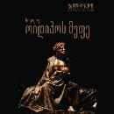 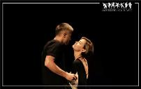 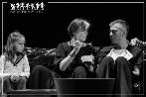

Director David Doiashvili

Scenography by Anna Ninua

Costumes Designer Anano Mosidze

Choreographer Kote Purtseladze

Composer Aleksandre Kozmanashvili

Assistant to the director Nino Chavchavadze

Characters and Cast:

Oedipus - Kakha Kintsurashvili

Jocasta - Nino Kasradze

Tiresias - Marina Jokhadze

Creon - David Beshitaishvili

A Messenger from Corinth - Tato Chakhunashvili

A Shepherd - Archil Sologhashvili

Antigone - Daro Doiashvili

Chorus:  Nata Berezhiani, Ana kurtubadze, Gigi Karseladze, Giorgi Toriashvili, Levan kakheli

About Performance:

If we realize, that we are killing fathers and marryng our own mothers without prophecy we will realize its not just mythical,

,,Oedipus Tirannus” by Sophocles !

It will not be just tragic

but the inevitable fate of our daily lives.

The only way we might change fate is to realize

that we have kids that one day will…! might…!

Duration: 140 min, without intermission The premiere was held on October 7, 2021

<https://www.youtube.com/watch?v=SLQagTTP97I>

***Bunker* Based on Iva Pezuashvili’s Novel, Directed by Mikheil Charkviani**

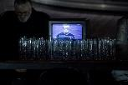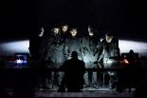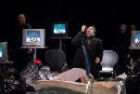

Costume Designer- Anano Mosidze

Music written and arranged by Nikoloz Rachveli

Pianist- Tamar Zhvania

The production features live performance of compositions by Olivier Messiaen.

Cast:

Gena- David Beshitaishvili

Mila- Buba Gogorishvili

Zema- Anastasia Chanturaia

Lazare- Giviko Baratashvili

Mamuka- Giga Datiashvili

The man from the Ministry- Aleksandre Begalishvili

Pita- Gigi Karseladze

Nugo- Devi Bibileishvili

About the play:

The ninth of April is memorial day. On this day in 1989, protesters at Tbilisi's Rustaveli Avenue were murdered by General Rodionov. Both Mila's birthday and her and Gena's wedding anniversary are on April 9, but he is in grief.

Today, no one recalls the occasion. At the end of the 1980s, in the city of Yerevan, Mila and Gena's romance blossomed like a holiday. However, it quickly broke down and disintegrated, much like the Soviet Union. A couple arrived in the city while escaping the Karabakh War. They moved into a refugee flat in the Tbilisi Sea neighborhood and have been living here ever since. Their oldest daughter, Zema, works as a police officer. Lazare, their son works as a delivery man. Its a family trapped in the ruins of Soviet Union trying to escape from the bunk of their homeland. the first theater production of the renowned novel "Bunker" by Iva Fezuashvili. It is a story of Georgians' daily lives in an independent Georgia.

**The duration of the performance- 170 minutes.**

**Macbeth - by Shakespeare, Directed by David Doiashvili**

**Information will be updated**

**Duration of the performance 140min**

[**https://www.youtube.com/watch?v=QTnW6ZnOX8M**](https://www.youtube.com/watch?v=QTnW6ZnOX8M)

**Antigone, by Sophocles, directed by Grigol Nodia**

 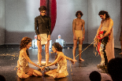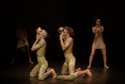 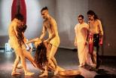

A post-dramatic text has been created using the matrix of Sophocles' Antigone, with the main aim of distancing itself from the myth. The actors do not represent specific characters, but rather they represent the narrative, noise and the space between events. The spectacle presented on stage is both a ritual and an act of emptying it of the sacred.

**Duration of the performance 100min.**

**SAVE THE DATES 1-4 February 2024**

We provide local hospitality and management, for selected and invited guests we are covering 4-night hotel and provide meals, selected programmers and guests number are limited.

Our theatre is located in 19 centuries historical beautiful district with unique theatre facilities and spaces. This is mostly friendly place for diverse cultural events.

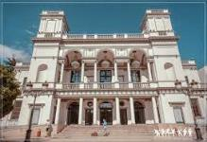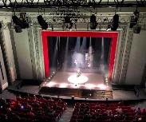

In case you are curious to take part in this program you could ask us for participation with registration fees and we will assist you after with free accreditation as well with discount logistics.

Our project partners are: UNESCO International Theatre Institute Georgian Centre, European Festival Association EFFE South Caucasus Hub, Arts Research Institute of Georgia.



Please contact us: [**internationaloffice@newtheatre.ge**](mailto:internationaloffice@newtheatre.ge)

Social network:

<https://www.instagram.com/vaso_abashidze_new_theatre/> <https://www.facebook.com/StateNewTheatre/>

**Registration for participation 1-4 February 2024, Tbilisi**

Name Surname

Organization

Position

Country

Address

Webpage

Are you interesting to invite Georgian Theatre in your country?

E-mail

Social Network

What’s up /other

**Please attached your short CV and Photo**

Please specify – you are: Programmer, Festival Director/representative, Independent Manager/Producer, Other………………………………………………………

Have you experience in past to work abroad with Georgian Theatre?

In case of “YES” – please specify company/project

Participants funded by the program of Festival/showcase is limited, please be sure that you will apply on time

You also can take part in our program through registration fee, with special discounts

**Deadlines for applications – 20 December of 2023**

**Working Schedule of Georgian New Theatre Festival/Showcase, Tbilisi, 2024**

|  |  |  |  |  |
| --- | --- | --- | --- | --- |
|  | 1st February | 2nd February | 3d February | 4th February |
| 11.00 |  | Round Table | Round Table | Round Table |
| 12.00 |  | Presentations | Presentations | Presentations |
| 13.00 |  | Lunch buffet | Lunch buffet | Lunch buffet |
| 14.00 |  | Afternoon Performance | Afternoon Performance | Afternoon Performance |
| 15.00 |  |  |  |  |
| 16.00 |  |  |  |  |
| 17.00 | Press Conference |  |  |  |
| 18.00 |  |  |  |  |
| 19.00 | Opening and Evening Performance | Evening Performance | Evening Performance | Evening Performance |
| 20.00 |  |  |  |  |
| 21.00 |  |  |  |  |
| 22.00 | Night program | Night program/ Show | Night program | farewell buffet party |
| 23.00 |  |  |  |  |
| 24.00 |  |  |  |  |

1. In the program possible some changes