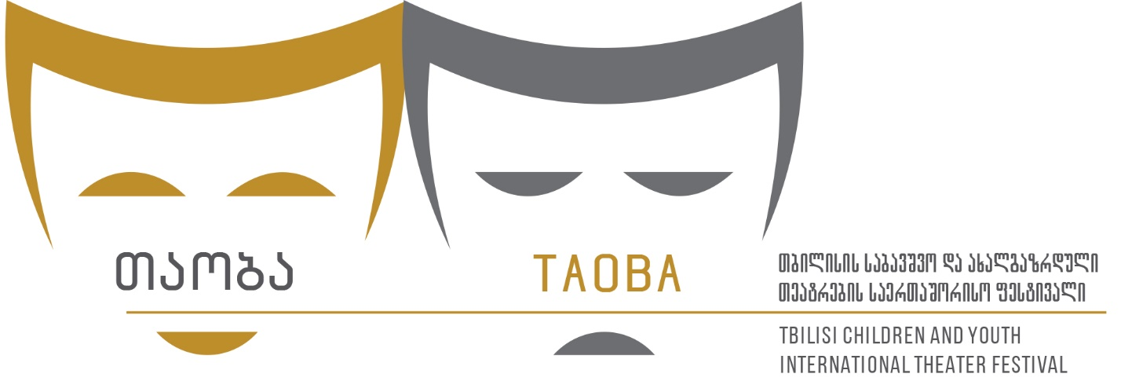

4th TBILISI CHILDREN AND TOUTH INTERNATIONAL THEATRE FESTIVAL
1-5 June 2024

APPLICATION FORM (Deadline 25 April 2024)

COMPANY INFORMATION
Company Name:
Company web address:
Country:
Address:
Phone/What’s Up:
E-mail:
Contact Person (his/her position):

Brief Company History:

PERFORMANCE DETAILS
Performance/Play Name:
Playwright:
Director:
Designers (decor, costume, light, music, choreography…):

Brief description of the performance: ( Synopsis)
Primary discipline:
Language:
Duration:
Cast list of the performance:

Total number of the group:
Names and duties of the members of the theater that will come to the festival:

- Does your performance have special requirements:
- Preferred dates of performance:
- Proposed venue/type of venue:
- Time required for:
- Set:
- Lights:
- Sound:
- Size of required acting area:
- Proscenium: - Backstage:
Technical specifications, stage & lighting plans:
Sound:

- Record of performance (Applications without full video will not be accepted)

- Photos , brochures, posters, any other supporting documentation. Please send the photos by e-mail: info.childrentheatrefestival@gmail.com

Social network: https://www.facebook.com/TCYITF
E-mail: info.childrentheatrefestival@gmail.com
Tel/Whats Up + : +995 595305000
